FCC Part 15B Certified (ID: POD-ANG7).

In order to meet the FCC policies, the frequency range of the TYT UV8000E radios we sell is locked in 144-148/420-450 MHz and the VFO function is disabled. But you can unlock the frequency range and enable the VFO if you need it.

Solution #1:

Turn on the radio with the PTT and 1 buttons pressed, then the radio will unlock the frequency range and enable the VFO function directly.

Solution #2:

1. Connect your radio to the programming software:

<https://s3.amazonaws.com/8000E/UV8000E%20software%20%5BNew%5D.zip>

2. Read from radio

3. Click the Setup--Model Information

4. Edit the frequency range:

Freq. Rang1: 136-174MHZ

Freq. Rang2: 400-520MHZ

Note: Do not edit the Freq. Rang3&4

5. Write to the radio

Please see the screenshot below for more information:

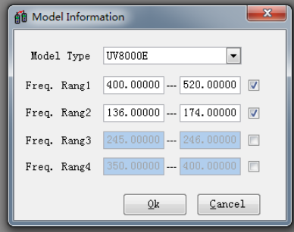

Hope you enjoy your new TYT UV8000E radio! If you need any further assistance or have any question, please feel free to let us know ([support@radioddity.com](mailto:support@radioddity.com)).

**NOTE: TYT UV8000E does not support programming with Chirp**